**Company : Domain**

1. Factory Motor Parts : OEM

Uses of predictive graph database- builds not only network visualization but also ‘walk’

the graph using machine learning- predict single point failure and their cascading effects

on inventory and infrastructure networks.

Efficient inventory management and building by predicting the dependencies and their effects across networks.

1. Buhler : services for processing foods and manufacturing advanced materials (agricultural equipment manufacturer)
2. Broadhead. : marketing agency focused on farm, food and lifestyle brands. Capabilities include brand strategy, content marketing, media planning & buying, design, digital & mobile, public relations, social media

Integrate data silos to holistic view about customers;build networks of customers

and company engagement, predict effectiveness of marketing strategies on probable customer base.

1. Bio-Techne - Life sciences manufacturer supplying consumables and instruments for the pharma, biotech, academic, and diagnostic markets

Present day medical data is expansive making traditional databases slow and complex to use. GraphDBs offer easy data exploration and visualization. Emerging biotechnologies like Next Generation Sequencing can work closely in sync with graphDBs to reduce data analysis cost and time for diagnosis and research.

1. H.B Fuller Company - Works on perfecting adhesives and deals with other chemical products to improve products and lives
2. BDI : company developing and deploying custom distribution and supply chain solutions.

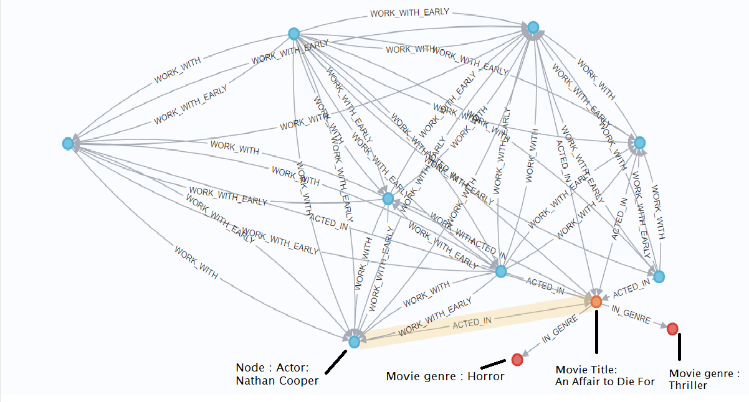

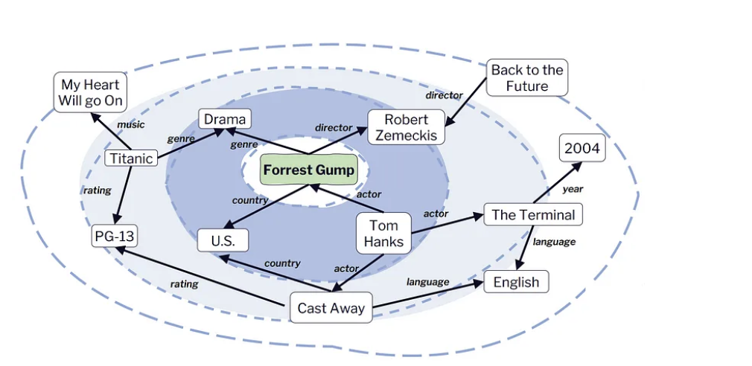

Neo4j's powerful graph database technology opens up a world of opportunities across various industries.

**Supply Chain Management Use case (BDI, Broadhead) :**

1. Shift in consumer buying pattern : The customer is now at the center of the value chain. However, real-time control of inventory, payment, delivery systems and overall responsiveness is complicated – especially if you're slowed down by legacy infrastructure.
2. Unstable supplier network : The need for precise information about the components used to manufacture a finished product is of paramount importance. The more steps there are in the supply chain, the greater the risk of instability.

Neo4j’s ability to manage complex data interdependencies means that when you track something, you can create a hierarchy or ‘tree’ of data. Scanning the code of a particular pallet will automatically recall its contents and supply chain lineage. Graphs are adept at mapping complex, inter-connected supply chains, and maintaining high performance even with vast volumes of data. Their inherent relationship-centric approach enables firms to better manage, read and visualize their data. This gives a trackable and in-depth picture of all products, suppliers and facilities and the relationships between them.

* 100 times faster query response speeds in contrast to a traditional SQL database.
* <https://youtu.be/m_r9ta5F4G0>

## **Graphs in Life Sciences: The Cure for Connecting Complex Data (for ex Bio-techne, H.B Fuller, Buhler)**

Overall use cass:

If you work in systems biology, you’re tasked with understanding the connections between genes, proteins, cells and tissues. If you work in chemistry, each individual molecule renders its own graph. Even healthcare organizations must map patient journeys to better understand disease progression or prevent poor outcomes. In each of these cases, you’re solving problems naturally represented by interconnected data.

The graph database specifically designed to store and process your connected data, helps solve complicated life sciences problems at every scale, for industries such as In pharmaceutical companies, chemical manufacturers, agriculture companies, biotech startups and healthcare providers.

Life science companies – dealing with everything from patients to molecules – understand the value of graphs for R&D, privacy and regulatory compliance, medical equipment manufacturing and affiliation management between healthcare providers (HCPs), patients and organizations. Neo4j has enabled companies like **Novartis** and ChemAxon to extract novel insights about relationships between biological and chemical data to accelerate drug discovery. We’ve also empowered companies like **Monsanto** to track genetic relationships in corn to breed better crops and feed the world’s growing population.

Supply chain management image:

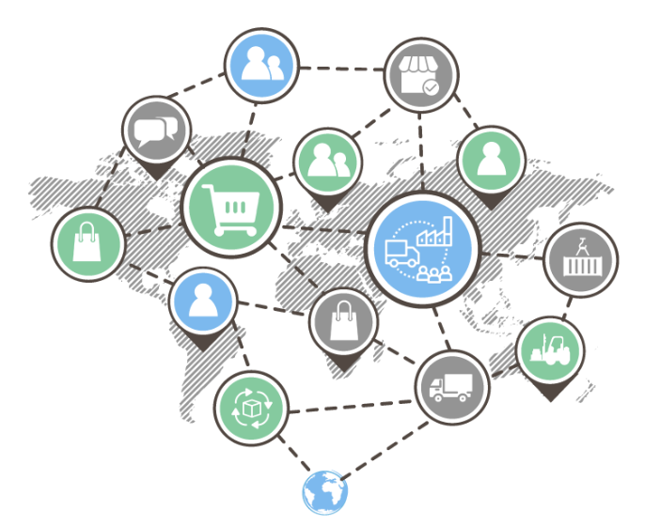

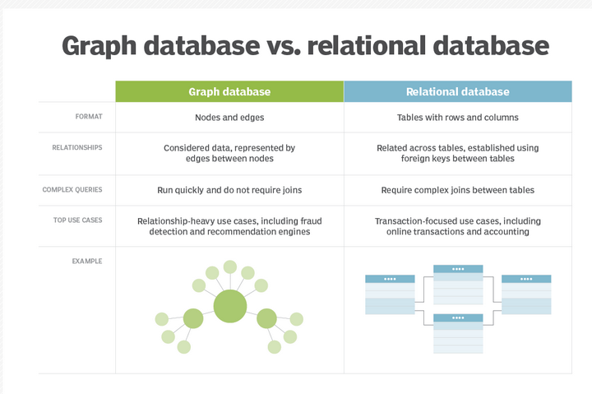

<https://towardsdatascience.com/movie-recommendations-powered-by-knowledge-graphs-and-neo4j-33603a212ad0>

Data management in netflix:

<https://www.kdnuggets.com/2019/08/linkedin-uber-lyft-airbnb-netflix-solving-data-management-discovery-machine-learning-solutions.html>

<https://neo4j.com/news/how-linkedin-uber-lyft-airbnb-and-netflix-are-solving-data-management-and-discovery-for-machine-learning-solutions/>

Life science : bio

<https://neo4j.com/use-cases/life-sciences/>

Why GraphDB?

Graph databases store relationships as data, allowing real-time addition of nodes and relationships, while relational databases focus on relationships between columns and allow adding tables and columns on the go.Relational databases (RDBMS) are tried and true in several situations. However, they grind to a halt when you’re aiming to unearth deep insights in complex data sets. [Graph databases](https://analyticsindiamag.com/want-to-learn-graph-databases-here-are-a-few-courses-to-go-for/) excel in executing complex queries, outperforming relational databases that rely on slower joins between tables.

graphDB and generative AI-

GraphDB intricately links with the present day AI revolution it offers a flexible toolkit that enables businesses to make predictions, solve intricate problems, and extract valuable insights. By leveraging graph algorithms and predictive features, organizations demonstrate the value of graphs in advanced analytics, machine learning, and AI.

GSD Library:

The Neo4j Graph Data Science (GDS) library provides efficiently implemented, parallel versions of common graph algorithms, exposed as Cypher procedures. Additionally, GDS includes machine learning pipelines to train predictive supervised models to solve graph problems, such as predicting missing relationships.

Our approach:

In our innovative project, we harness the power of Neo4j, a leading graph database platform, to predict and uncover potential future collaborations between actors, using an extensive movie dataset sourced from Netflix.

By leveraging the Graph Data Science Library and APOC (Awesome Procedures on Cypher), our approach is to analyze the intricate relationships and connections present within the movie industry.

Through the fusion of graph theory, data science, and advanced querying capabilities, we aim to provide insights into the likelihood of future collaborations between actors, offering valuable strategic information to stakeholders in the entertainment industry.

Drug discovery: The Cure for Connecting Complex Data

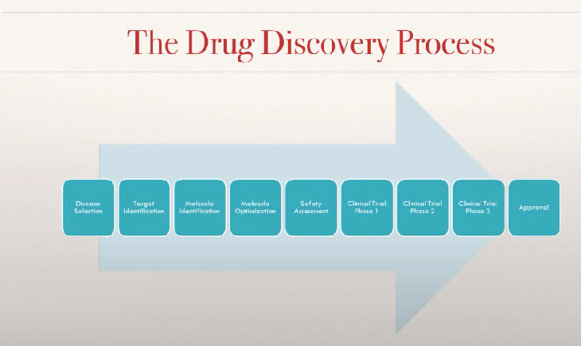

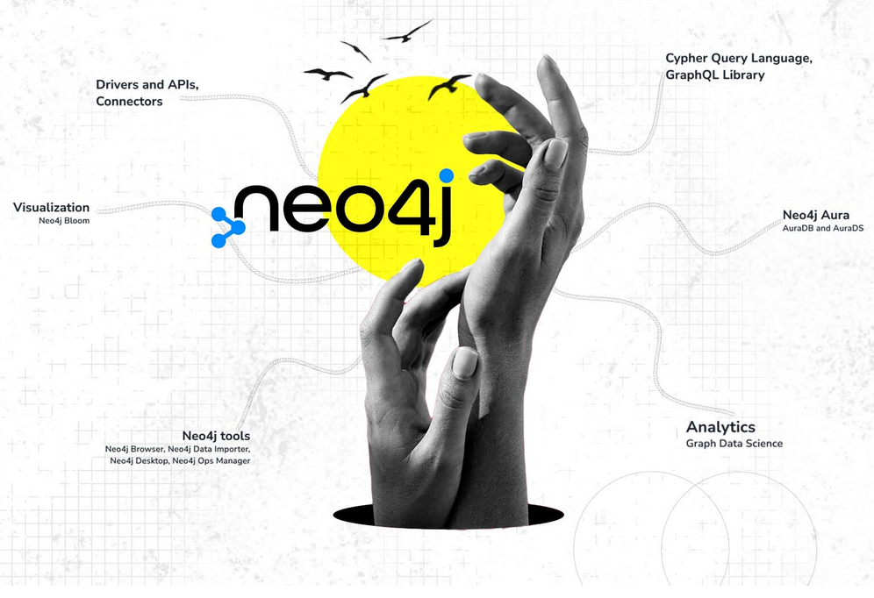

Link to our website: <https://aditi070696.wixsite.com/my-site-1>

Introduction

Today’s businesses are faced with extremely complex challenges and opportunities that require more flexible, intelligent approaches. That’s why Neo4j created the first enterprise graph framework for data scientists – to improve predictions that drive better decisions and innovation. Neo4j Graph Database is the only graph database that is trusted by enterprises for its **speed, security, and scalability** to support the most challenging transactional and analytical workloads.

Using Neo4j for Graph Data Science incorporates the predictive power of relationships and network structures in existing data to answer previously intractable questions and increase prediction accuracy.

The property graph model stores nodes and their corresponding relationships together, so you just follow the pointers for real-time queries.

Business Outcomes:

### **Improve Predictions -**

### predictive power of relationship in advanced analytics and machine learning enables you to continually improve predictive accuracy.

### **Answer Intractable Questions -** understand complex systems and answer more complicated questions.

### **Confidently Operationalize -** add graph based features to existing data science pipelines is a low-risk way to put more accurate models into production faster.

Challenges:

### **Limited Data**

### **Iteration**

Data science is inherently iterative so it’s essential to use a framework that brings in highly predictive relationships while streamlining the process of moving from data to analysis to visualization and back.

Link– <https://drive.google.com/drive/u/2/folders/1k3rw5SU1K-SJY2rJVDQlM1peBqZxQYfD>

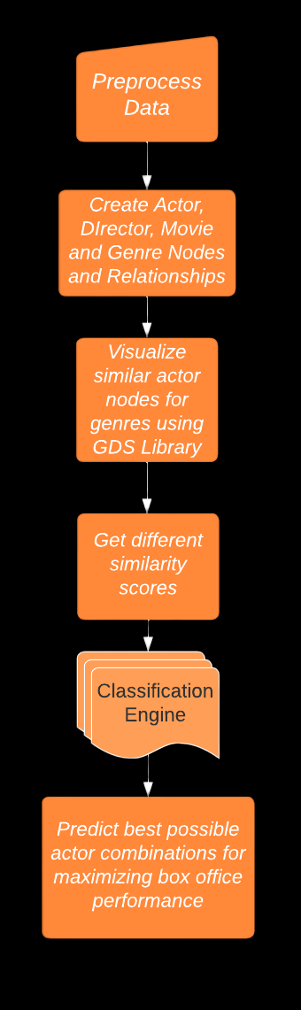

* **Objective**: use graph features to predict future collaboration between actors based on previous collaboration.
* 4 models are trained and tested using different set of graph features.
* The last section presents the importance of each of the features used on the prediction performance.
* The graph parameters used are: Common neighbors, preferential attachment, total neighbors, triangles count, clustering coefficient, Louvain coefficient, and partition community detection.